Continue Installation Instructions
Check PyCharm Version
Make sure you are using the latest stable release of PyCharm (version 2026.2.3 as of September 27, 2026)
To check this:
- Click on the to open the Main Menu
o On Mac, this will be in the top menu bar in PyCharm -> About
- Go to Help -> About to get the below pop-up:
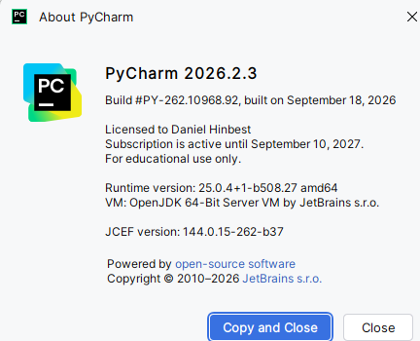
If it is not up-to-date, update your IntelliJ installation by doing the following: - Click on the to open the Main Menu
- Go to Help -> Check for Updates…
o On Mac, this will be on the top menu bar
If you receive the following pop-up on the bottom of your screen, your IntelliJ is already up-to date:

Installing Continue
To install Continue, go to the Google Drive link provided to you.
- Download the plugin’s zip file and save it in a location where you can easily find it Open your course project in PyCharm and install the plugin.
NOTE: Do not unzip the Continue file.
- For Mac users, if Safari unzips it automatically
  - Go to Safari -> Settings -> General -> Uncheck “open safe files after download”
- Click on the icon and select Plugins… to open the Plugins menu - Click on the icon in the Plugins menu and select Install Plugin from Disk…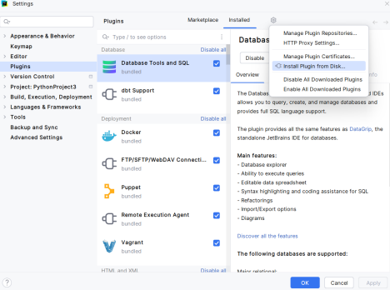
- Locate continue.zip in the file explorer and click OK
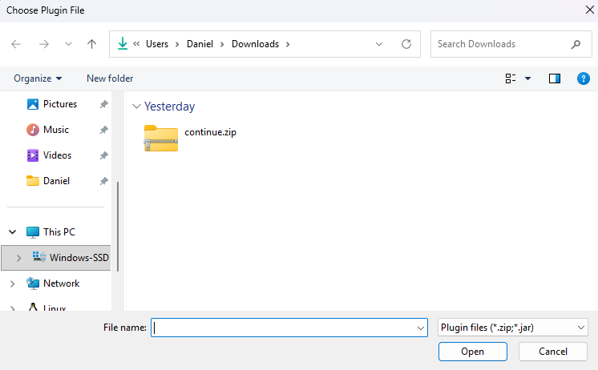
- Continue should now be installed, verify by checking for the icon on the right sidebar. If it prompts you to restart, do so and it will be installed after the restart

Using Continue
Once Continue is installed, it will be accessible on the right side of IntelliJ and can be found with this icon
In the Google Doc with the task instructions, you will be provided an OpenAI API Key. Add it to Continue to access the AI features.
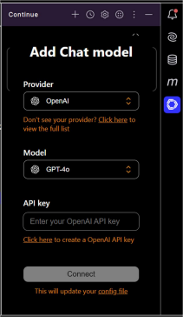
You are encouraged to use the context reference for files (using ‘@’ ) and reference previous prompts (using ‘/’). More information on how to optimally use Continue.dev can be found at : How to Use Continue.dev AI IDE
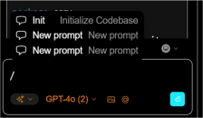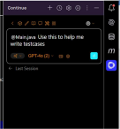
Uninstalling Continue
Once the tasks have been completed, you can uninstall Continue.
- Click on the icon at the top of PyCharm and select Plugins… and switch to the Installed tab
You will see Continue in the list of plugins

- Click on the plugin, click the and select Uninstall
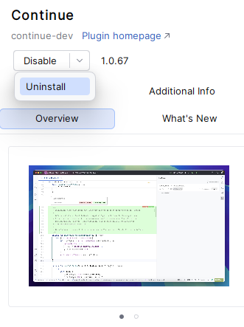
After the plugin has been uninstalled, click on Restart IDE and then Restart to complete the uninstallation process.

